**Lab practical 06**

**COA**

**Question:**

**1 (a) Write a program in assembly language to print single character on screen.**

**Code:**

**org 100h ; Set program origin for COM file**

**; Move the character 'S' into DL**

**mov dl, 'S' ; Character to be printed**

**; Set AH to 02h (function for displaying character)**

**mov ah, 02h ; DOS interrupt function to print a character**

**; Call the interrupt to print the character**

**int 21h ; Interrupt to print the character**

**; Terminate the program**

**mov ah, 4Ch ; DOS interrupt function to exit program**

**int 21h ; Terminate the program**

**OUTPUT:**

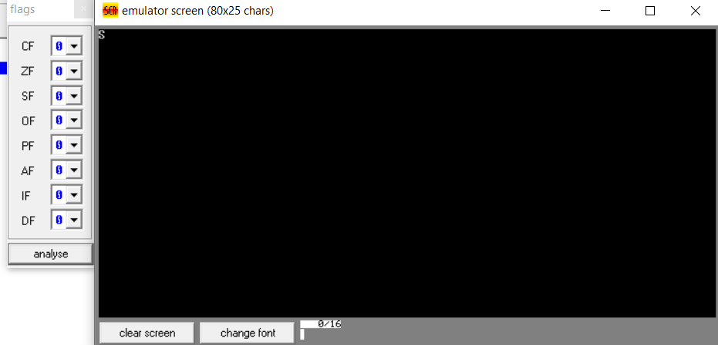

1. **(b) Write an assembly language program to convert an upper-case letter to corresponding lower-case letter.**

**CODE:**

**ORG 100h ; Origin, to specify that the program starts at 100h (COM file format)**

**; Display message "Enter an uppercase letter: "**

**MOV DX, OFFSET msg_input ; Load the address of the message**

**MOV AH, 09h ; Function 09h of INT 21h is used to display a string**

**INT 21h ; Call DOS interrupt to print the message**

**; Read a single character from the user**

**MOV AH, 01h ; Function 01h of INT 21h is used to read a character**

**INT 21h ; Call DOS interrupt to get the character**

**MOV DL, AL ; Store the input character in AL**

**; Check if the character is an uppercase letter (A-Z)**

**CMP AL, 'A' ; Compare AL with 'A'**

**JL NotUpperCase ; If the input is less than 'A', it is not uppercase**

**CMP AL, 'Z' ; Compare AL with 'Z'**

**JG NotUpperCase ; If the input is greater than 'Z', it is not uppercase**

**; Convert the uppercase letter to lowercase**

**ADD AL, 20h ; Add 32 (20h) to convert uppercase to lowercase**

**MOV BL,AL**

**; Print the message "The lowercase letter is: "**

**MOV DX, OFFSET msg_output ; Load the address of the output message**

**MOV AH, 09h ; Function 09h of INT 21h is used to display a string**

**INT 21h ; Call DOS interrupt to print the output message**

**MOV AL,BL**

**; Print the converted lowercase letter**

**MOV DL, AL ; Move the lowercase letter to DL**

**MOV AH, 02h ; Function 02h of INT 21h is used to print a single character**

**INT 21h ; Call DOS interrupt to print the character**

**JMP EndProgram ; Jump to the end of the program**

**NotUpperCase:**

**; If the input is not an uppercase letter, display an error message**

**MOV DX, OFFSET msg_error ; Load the address of the error message**

**MOV AH, 09h ; Function 09h of INT 21h is used to display a string**

**INT 21h ; Call DOS interrupt to print the error message**

**EndProgram:**

**; Terminate the program**

**MOV AH, 4Ch ; Function 4Ch of INT 21h terminates the program**

**INT 21h ; Call DOS interrupt to exit**

**msg_input DB 'Enter an uppercase letter: $'**

**msg_output DB 0Dh, 0Ah, 'The lowercase letter is: $' ; Output message**

**msg_error DB 0Dh, 0Ah, 'Error: Not an uppercase letter! $' ; Error message**

**END ; End of program**

**OUTPUT:**

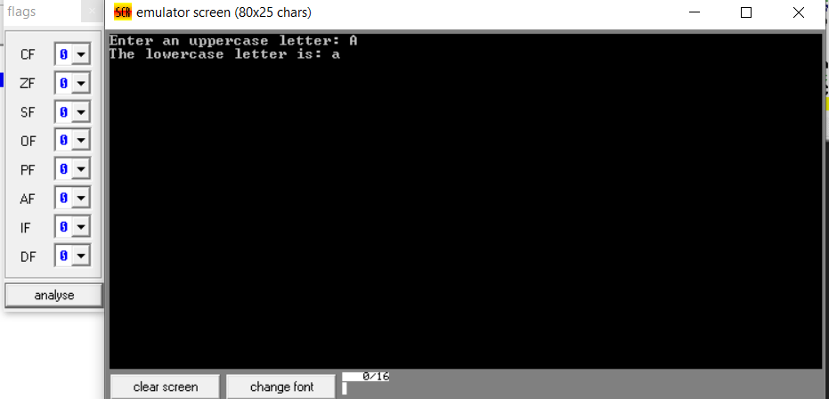

1. **(a) Write a program in assembly language to print multiple characters on screen.**

**CODE:**

**ORG 100h ; Origin, to specify that the program starts at 100h (COM file format)**

**; Print "Enter the input: "**

**MOV AH, 09h ; DOS function 09h: print string**

**MOV DX, OFFSET msg_enter_input ; Load address of the string**

**INT 21h ; Call DOS interrupt to print the string**

**; Read multiple characters from user**

**MOV AH, 0Ah ; DOS function 0Ah: buffered input**

**MOV DX, OFFSET input_buffer ; Load address of the input buffer**

**INT 21h ; Call DOS interrupt to read the string**

**; Add a $ at the end of the entered string for printing**

**MOV AL, '$' ; Store $ in AL**

**LEA DI, input_buffer+2 ; DI points to the actual input string**

**MOV CL, [input_buffer+1] ; Get the count of characters entered**

**ADD DI, CX ; Move DI to the end of the entered string**

**MOV [DI], AL ; Insert $ at the end of the string**

**; Print "The entered input is: "**

**MOV AH, 09h ; DOS function 09h: print string**

**MOV DX, OFFSET msg_entered_input ; Load address of the second string**

**INT 21h ; Call DOS interrupt to print the string**

**; Print the entered string**

**LEA DX, input_buffer+2 ; Load address of the actual input (skip buffer size and count)**

**MOV AH, 09h ; DOS function 09h: print string**

**INT 21h ; Call DOS interrupt to print the input string**

**; Terminate the program**

**MOV AH, 4Ch ; DOS function 4Ch: terminate program**

**INT 21h ; Call DOS interrupt to exit**

**; Data section**

**msg_enter_input DB 'Enter the input: $' ; Prompt message**

**msg_entered_input DB 0Dh, 0Ah, 'The entered input is: $' ; Newline and display message**

**input_buffer DB 10, 0 ; Buffer to store input: 10 max chars, initial count 0**

**; The actual characters will be stored starting here**

**; Followed by a terminator (CR)**

**END ; End of program**

**OUTPUT:**

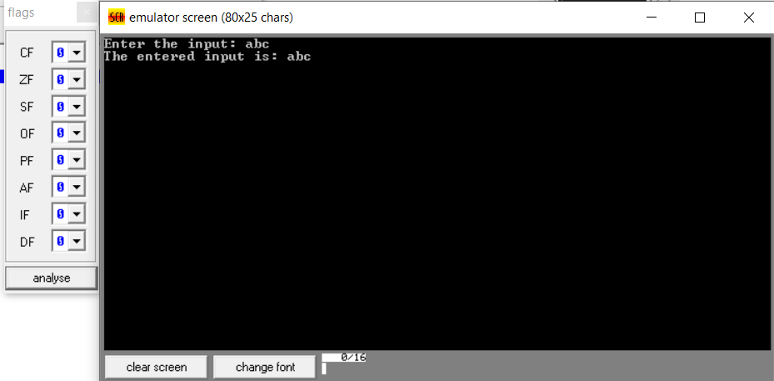

**(b) Write an assembly language program to convert lower-case letters to upper-case letters.**

**CODE:**

**ORG 100h ; Origin, to specify that the program starts at 100h (COM file format)**

**; Display message "Enter a lowercase letter: "**

**MOV DX, OFFSET msg_input ; Load the address of the message**

**MOV AH, 09h ; Function 09h of INT 21h is used to display a string**

**INT 21h ; Call DOS interrupt to print the message**

**; Read a single character from the user**

**MOV AH, 01h ; Function 01h of INT 21h is used to read a character**

**INT 21h ; Call DOS interrupt to get the character**

**MOV DL, AL ; Store the input character in AL**

**; Check if the character is a lowercase letter (a-z)**

**CMP AL, 'a' ; Compare AL with 'a'**

**JL NotLowerCase ; If the input is less than 'a', it is not lowercase**

**CMP AL, 'z' ; Compare AL with 'z'**

**JG NotLowerCase ; If the input is greater than 'z', it is not lowercase**

**; Convert the lowercase letter to uppercase**

**SUB AL, 20h ; Subtract 32 (20h) to convert lowercase to uppercase**

**MOV BL,AL**

**; Print the message "The uppercase letter is: "**

**MOV DX, OFFSET msg_output ; Load the address of the output message**

**MOV AH, 09h ; Function 09h of INT 21h is used to display a string**

**INT 21h ; Call DOS interrupt to print the output message**

**MOV AL, BL**

**; Print the converted uppercase letter**

**MOV DL, AL ; Move the uppercase letter to DL**

**MOV AH, 02h ; Function 02h of INT 21h is used to print a single character**

**INT 21h ; Call DOS interrupt to print the character**

**JMP EndProgram ; Jump to the end of the program**

**NotLowerCase:**

**; If the input is not a lowercase letter, display an error message**

**MOV DX, OFFSET msg_error ; Load the address of the error message**

**MOV AH, 09h ; Function 09h of INT 21h is used to display a string**

**INT 21h ; Call DOS interrupt to print the error message**

**EndProgram:**

**; Terminate the program**

**MOV AH, 4Ch ; Function 4Ch of INT 21h terminates the program**

**INT 21h ; Call DOS interrupt to exit**

**msg_input DB 'Enter a lowercase letter: $'**

**msg_output DB 0Dh, 0Ah, 'The uppercase letter is: $' ; Output message**

**msg_error DB 0Dh, 0Ah, 'Error: Not a lowercase letter! $' ; Error message**

**END ; End of program**

**OUTPUT:**

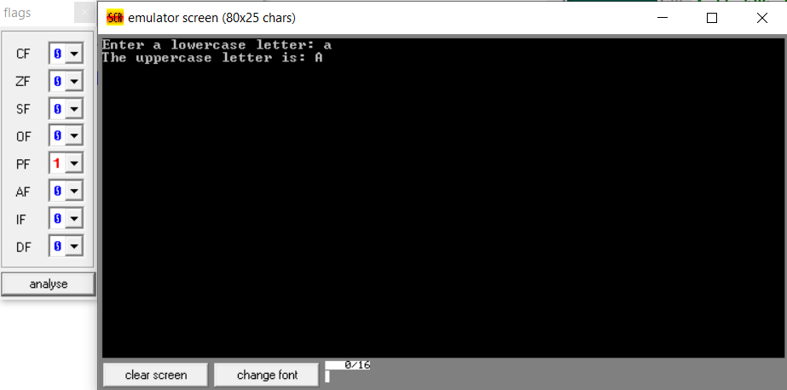

**GITHUB:**

[**https://github.com/srijachakilam15/COA/blob/main/lab%20practical%2003.docx**](https://github.com/srijachakilam15/COA/blob/main/lab%20practical%2003.docx)

s